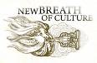
Project
“NEW breath of culture: fill heritage with life of art”

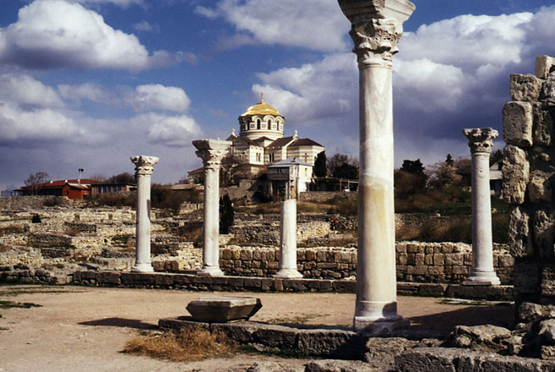
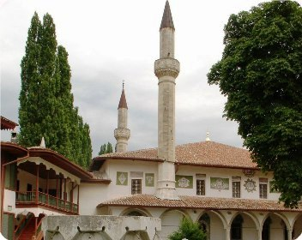
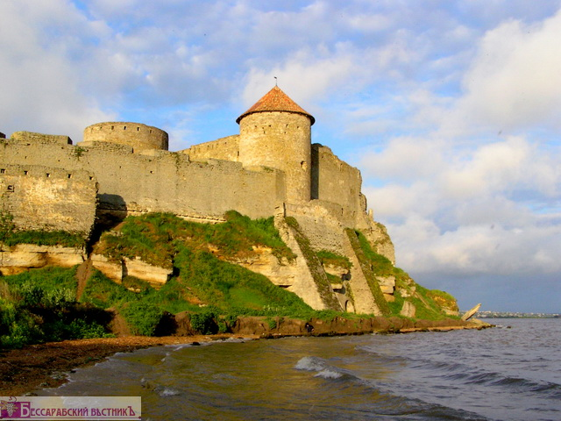
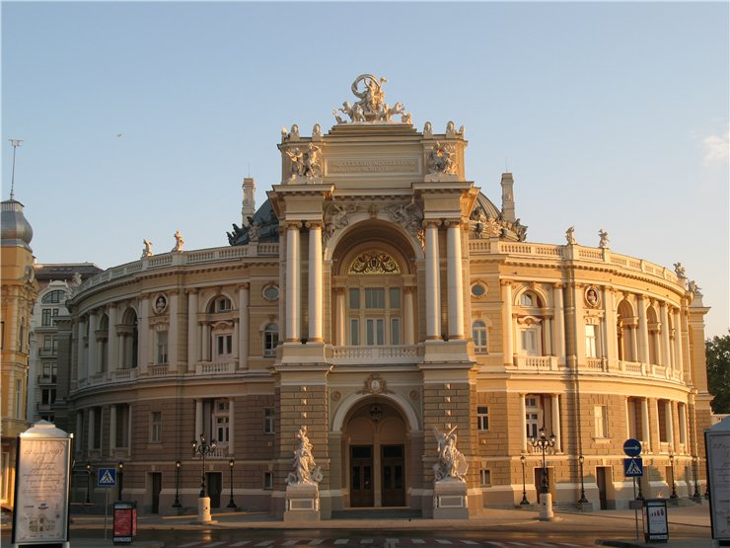
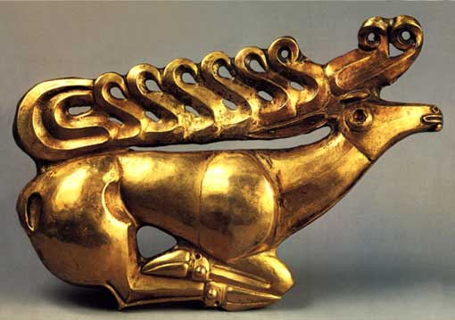
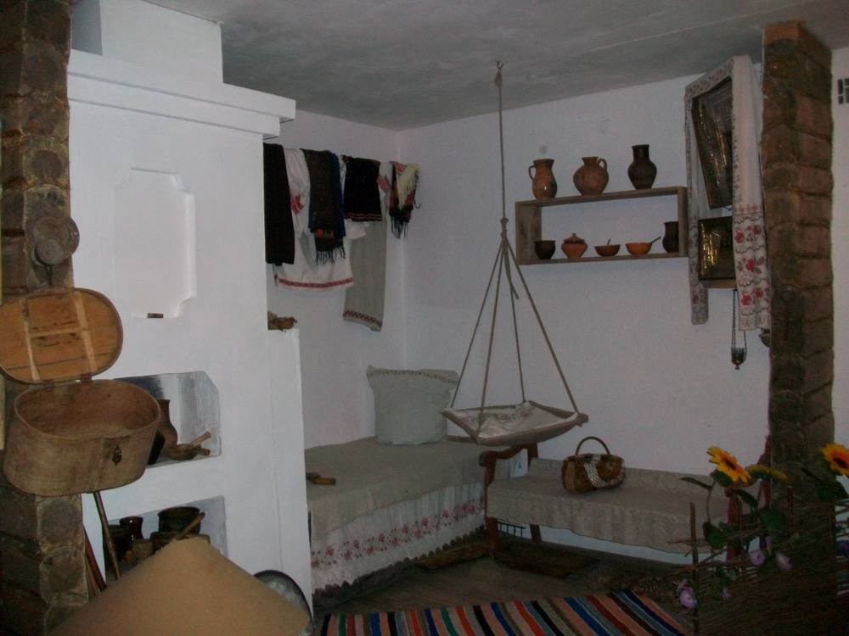

Announcement
OF PROJECT PROPOSAL COMPETITION
FOR RECEIVING GRANT

Project proposal submission deadline:

December 10th, 2012
17:00 (Kyiv time)

1. GENERAL INFORMATION OF THE PROJECT “New breath of culture: fill heritage with life of art”

The Project “New breath of culture: fill heritage with life of art” is implemented in partnership with:

- Kherson City Center of Youth Initiatives “Totem”, Ukraine (leading partner);
- Charity Fund “CCC Creative Center”, Ukraine;
- Association Droni, Georgia;
- Armenian Young Women's Association (AYWA), Armenia.

Project implementation period: January 2012 – December 2013

Donor: the European Union

Territories covered by the project:

- South of Ukraine (Autonomous Republic of Crimea, the Nikolayev, Odessa, Kherson oblasts, Sevastopol);
- Armenia;
- Georgia.

Project goals:
- To develop effective system of definition, gathering, analysis and dissemination of best practices of using art innovations for promotion of cultural and historical heritage in the south of Ukraine, Georgia and Armenia.
- To develop the international and intersector cooperation on the basis of common platform of generating and realizing cultural activities for the sake of social and economic development.

Project objectives:
- To promote creation of appropriate conditions for development of innovative cultural activity through creation of new communications between culture and tourism sectors, to increase influence on the formation of local policy.
- Expansion of access to culture by development of non-formal education system for youth.
- Strengthening of regional communications and development of intercultural dialogue within the region of the Eastern Partnership through creation of virtual network and web-site.
- Dissemination of best practices of using art innovations and cultural activity on the basis of traditional cultural and historical heritage with the purpose of “filling it with life” and increasing of its attractiveness for community (especially youth).

Planned activities:
- Training program on the management bases in the culture sphere for representatives of nongovernmental organizations, museums and initiative groups selected.
- Creation of web-site-platform for best practice sharing.
- Introduction of non-formal education program on the basis of museums of Georgia, Armenia, the South of Ukraine for youth of three countries.
- Grant program for support of project participants’ initiatives.
- Holding of the International Forum “Culture for Development” (Ukraine).

2. Goals and Priorities of Project Proposal Competition

The goal of the competition is to promote realization of partner initiatives of museums and nongovernmental organizations aimed at search and introduction of new (innovative) forms of presentation and popularization of traditional heritage, local community involvement in museums, activization of cooperation of museums with creative groups.

During competitive selection priority will be given to project proposals which provide:
- Close cooperation of NGO or charity fund with a museum.
- Search of new (innovative) forms of presentation and popularization of traditional cultural/historical heritage. Creative ideas are welcomed.
- Development and implementation of modern art and cultural projects on the basis of traditional cultural/historical heritage.
- Involvement in amuseum of local community not only as spectators, but also as active participants, initiators and organizers of actions, festivals, creative and club actions both in a museum and in community if such actions promote popularization of cultural/historical heritage.
- New forms of work with target groups (adults, children, disabled people, youth, etc.).

3. Grant Size

The minimal grant sum for which an applicant organization can apply is 20 000 UAH.
The maximal grant sum for which an applicant organization can apply is 100 000 UAH.

The grant sum should make no more than 90% of all necessary costs included in the project budget. The rest 10% of costs should be financed by an applicant organization due to money raised from other sources (except for grant programs funded by the European Union).

4. Who can participate in Project Proposal Competition

Participating in project proposal competition and, accordingly, being a grant applicant is possible for NGOs and charity organizations which:
- are registered and carry out their activity in the territory of the Autonomous Republic of Crimea, the Nikolayev, Odessa, Kherson oblasts and the city of Sevastopol;
- are non-profit organizations (have code of unprofitableness 005 or 006) and are included in the Register of non-profit organizations and institutions;
- have opportunities and are capable to raise additional finance for the project implementation.

Project proposals are not accepted from religious organizations, political parties and their local branches, local government bodies and executive authorities, municipal institutions and enterprises, museums as establishments.

Participating in project proposal competition and, accordingly, being a grant applicant is not possible for NGOs and charity organizations which:
- are under liquidation;
- made any efforts or made actions to influence on members of the Estimates Committee or the Competition Organizer, the Competition Manager with the purpose of illegal decision-making for their own advantage.

An applicant organization should have official partners in the project implementation. The organization partners should be obligatory museums of different types of property (municipal institutions which have local funding, national museums, private museums, etc.). Creative informal groups can also be partners. An applicant organization’s partners are obliged to participate directly in the project development and implementation, and may provide co-funding for the project implementation. Such partnership should be testified by a corresponding partnership agreement (joint activity agreement) in which spheres of responsibility and objectives for each of partners should be precisely specified.

5. ORDER OF PROJECT PROPOSAL SUBMISSION FOR COMPETITION
For participation in the competition an applicant organization which meets the requirements listed in the item 4 should submit a project proposal filled in according to the established sample (Annex 1). A project proposal includes:
- general information of applicant organization;
- project description;
- project budget;
- obligatory annexes:
- Copy of the Certificate of the State Registration or Extracts from the State Register.
- Copy of the decision of the Ukrainian State Tax Inspection about inclusion in the Register of non-profit organizations and institutions.
- Partnership Agreement between applicant organization and museum, and if necessary, with other project partners.
- Current bank account (in UAH).

The project proposal form can be received through direct addressing the Competition Manager – Charity Fund “CCC Creative Center”, by e-mail info@ccc.kiev.ua or on such web-sites:
www.totem.kherson.ua
www.welcomeculture.org
www.ccc-tck.org.ua www.gurt.org.ua www.civic.ua
Project proposal should be filled in Ukrainian or Russian.
Project proposal should be submitted printed in duplicate in А4. The proposal electronic version (CD) also should be presented. Hand-written proposals will be rejected.
In case the information in the project proposal is submitted not in full or the Estimates Committee requires more detailed information concerning these or those proposal aspects, a letter of inquiry with the request to give the additional information will be sent to an applicant organization.

Project proposal with all necessary annexes should be:
- sent by mail
or
- delivered by the courier
to the address: Kyiv, Ukraine, 02140, Bazhan's prospectus, 30, of. 8.
It is necessary to specify “Project Proposal Competition of the Project “New Breath of Culture” on the envelope.
Project proposals submitted any other way (by e-mail, fax, etc.) will be rejected.

6. PROJECT PROPOSAL SUBMISSION TERM
Project proposals with all necessary annexes should be submitted to the Competition Manager – Charity Fund “CCC Creative Center” not later than 17:00 (Kyiv time) on December, 10th, 2012.
Project proposals arriving after the specified deadline dates will not be accepted.
The date specified on the postage stamp will not be taken into consideration.
7. PROJECT PROPOSAL FILLING REQUIREMENTS
During the project development and project proposal filling an applicant organization should take into consideration the conditions given below.

General project duration cannot be longer than 6 months. The project activity should not begin before March, 1st, 2013.

Types of activities which can be financed due to the grant:
- Cultural and art events of any format if they are connected with museum’s subjects and are not limited to the single action (have potential for continuation).
- Organization of clubs, places of meetings, creative workshops, public discussions, etc.
- Information campaigns if they are an element of wider activity. Creation of web resources (sites, pages) needs proving.

This list is not exhaustive.

Activities which cannot be financed due to the grant:
- international business trips, study visits;
- granting the material and humanitarian help;
- scholarships and costs of similar sort;
- commercial or profitable activities;
- covering debts or creditor debts;
- pre-election or political activity;
- salaries, applicant organization employee fees, fees for its partners who are civil servants or local self-government employees, law enforcement agencies employees, Public Prosecutor’s Office employees, court employees.

Costs which can be included in the budget and are acceptable:
- Necessary staff salaries, fees of experts and consultants involved. Such costs should not differ essentially from average salary in the region for identical types of activities in corresponding areas.
- Staff and project participants’ costs and trips. Such costs should not exceed the sums stipulated by the legislation.
- Consumables.
- Equipment.
- Subcontract and direct costs for organizing and holding actions, etc.
- Administrative costs (phone, Internet, postage, bank services).
Following types of costs are unacceptable:
- Purchase of alcoholic beverages and tobacco products.
- Purchase of vehicles.
- Purchase of ground areas and real estate.
- Covering debts.

Obligatory condition is partnership in the project activity between an applicant organization and a museum.

8. Project proposal estimation PROCEDURE, DEFINITION OF WINNERS AND GRANTING FINANCING ORDER
After receiving by the Competition Manager of all project proposals and carrying out estimation of their conformity with the competition conditions, each applicant organization will be sent the decision (in writing) on admission/non-admission of its project proposal to the further estimation.

Project proposal estimation procedure consists of several stages.
At the first stage each project proposal is estimated by the Competition Administration by following criteria:
- Conformity of project proposal with the established form.
- All necessary documents are submitted in full (see item 5).
- Conformity of applicant organization with the established criteria (see item 4).
- The grant sum applied does not exceed the established size (see item 3).
By results of the first stage of estimation the Competition Manager makes a decision on admission/non-admission of project proposals to the further estimation.

At the second stage each project proposal admitted is estimated by members of specially created Estimates Committee by following criteria:

# | Criteria | Maximal point
 | Organizational capability of applicant organization to implement the submitted project. | 5
 | Project urgency and validity. | 10
 | Project methodology (how much effective planned activity is in achievement of established project goals and objectives; efficiency, logicality and practical acceptability of actions planned within the project, level of involvement of community or target groups). | 30
 | Clearness of definition of achievement indicators, project efficiency estimation indicators. | 10
 | Capability of activities planned to activate participation of community in museum work. | 10
 | How much project activity promotes development of cooperation between museums and NGOs. | 10
 | Sustainability of project in immediate prospect. | 10
 | Validity of budget and necessary resources. | 15
Total result |  | 100

On the basis of the results of project proposal estimation and reports of the results of monitoring visiting applicant organizations the Estimates Committee will make the list of grantee organizations.
Additional negotiations will be held with organizations-winners with the purpose of completion of their projects in view of the remarks made by the Estimates Committee. After completion of proposals a grantee organization will sign the agreement with the Kherson City Youth Initiatives Center “ТОТЕМ” about granting financing.
The grant sum will be transferred by two tranches to a grantee organization’s current bank account. The first tranche will make 90% of total grant sum. The second tranche will be transferred after a grantee organization submits to the Competition Manager descriptive and financial reports of project implementation and these reports are approved.

9. applicant organization CONSULTING
Till November, 9th 2012 applicant organizations can address the Competition Manager for the additional information or with questions with the purpose of specification of competition conditions, project proposals submission procedure.
Such consultation will be conducted by phone (contact phone 0 (44) 574 64 11) or by e-mail info@ccc.kiev.ua.
All questions and answers to them will be placed on the web site of the Competition Manager www.ccc-tck.org.ua.

10. THE ROUGH COMPETITION SCHEDULE

Date | Event
November, 23th, 2012 | Competition announcement.
December, 20th, 2012 | Last day for applicant organization consultation.
January, 8th, 2013 | Last day of reception of project proposals for participation in competition.
January, 15th, 2013 | First stage of project proposal estimation.
January, 21th, 2013 | Informing of applicant organizations of the results of the first stage of project proposal estimation.
January, 29th, 2013 | Second stage of project proposal estimation.
February, 1st, 2013 | Grant award decision-making. Signing of agreement.
February, 4-25th, 2013 | Holding negotiations and signing of grant award and project financing agreements.

